We’ve updated and expanded the content of our

Web Import Tool Guide
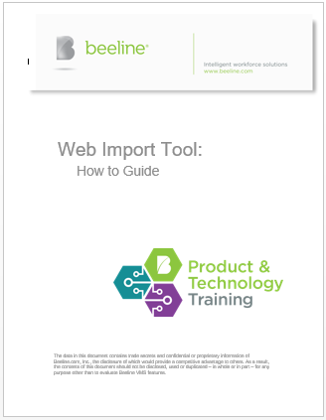
Please use the following link to download a copy of the new guide:
https://webapps.beeline.com/beelinetms/!_ProductTechnologyTraining/ContinuingEducation-WebImportTool.pdf
