This document contains confidential and/or proprietary information of Beeline.com, Inc., which is intended only for internal use by the direct recipient. This document and the information contained herein may not be published or disclosed to third parties without the prior written consent of Beeline.com, Inc., or used for any purpose other than that for which it was provided.
IQN Admin Basics

Contents
Introduction 1
Model = SaaS (Software as a Service) 1
Architecture = Tenancy 1
IQN Hierarchy Structure 2
IQN Configuration Hierarchy Levels 2
Account Set Up 3
IQN User Roles 5
Login: Choose Buyer Organization 5
User Interface (UI): Legacy and Alternate 6
Sample Hiring Manager Dashboard (Alternate UI) 6
Sample Supplier Dashboard (Legacy UI) 7
IQN System Status Definitions 7
Configuration: Profiles, Buttons, & Business Rules 7

Introduction
This document explains basic concepts helpful to users that are assigned IQN Administrator tasks and/or roles. Instructions on how to manage an active IQNavigator customer site can be found in the IQNavigator Admin Configuration Guide.

Model = SaaS (Software as a Service)
IQNavigator is based on a Software-as-a-Service (SaaS) model where Beeline “owns” the software and the customer retains ownership of their data. The software resides on Beeline-maintained servers and the customer is given ACCESS to the software.

Architecture = Tenancy
Single vs. Multi-Tenant
IQNavigator uses multi-tenant architecture where one server—or server cluster—is partitioned to store applications and data for multiple customers. Although the data and applications are housed on the same server, partitioning prevents data migration. A standard SaaS architecture is provided, including the same configuration capabilities for the hardware, network, and operating system for all customers (known as tenants). Multi-tenant architecture is similar to a condominium—one building that houses multiple families and supports them with the same amenities.
Beeline VMS uses single-tenant architecture where each customer, or tenant, resides in a separate instance of a software application and the supporting infrastructure. This is more like a neighborhood of single-family homes developed by the same architect with both the home and its utility services separate from its neighbors. Each household can customize their property as desired. By having a single hosted instance, the client can tweak and customize the software to meet their needs.
Key Differentiators:

Multi-tenant:
• Same code and database across all tenants, individual tenants may have limited ability to customize the software to their specific needs – separation is logical (code-based), rather than physical.
• “Share” amenities in common.

Single-tenant:
• Maximum privacy and data security based on complete physical and logical separation of each client’s instance of the UI.
• No “co-mingling” of data.

IQN Hierarchy Structure
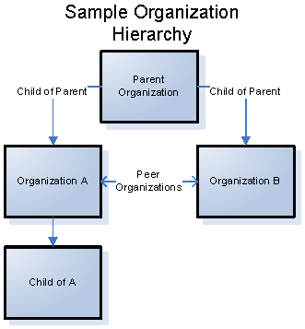

A hierarchy in IQNavigator determines the relationship between multiple organizations. Organizations are defined in a hierarchy as ‘parent’, ‘child’, or ‘sibling’ organizations. There are two basic organization types, Buyer and Supplier.
Organization is also the IQNavigator term for a customer. Each customer is represented in the IQN system by a buyer organization or a hierarchy of multiple buyer organizations.
An enterprise is defined as a single organization or a collection of multiple organizations that exist in a single hierarchy. There is typically one enterprise per customer.
Collections of hierarchies are grouped into managing firms. Each partner is typically given its own managing firm to allow it to administer and maintain all of its customers, and the suppliers supporting those customers, without granting access into data of others.

IQN Configuration Hierarchy Levels
Use the IQN Configuration Hierarchy charts to become familiar with the hierarchy levels and components that are managed under each level. There is separate chart for each IQN solution CWM (Contingent Workforce Management), Projects, and Light Industrial.

Click here to download all three configuration hierarchy charts.
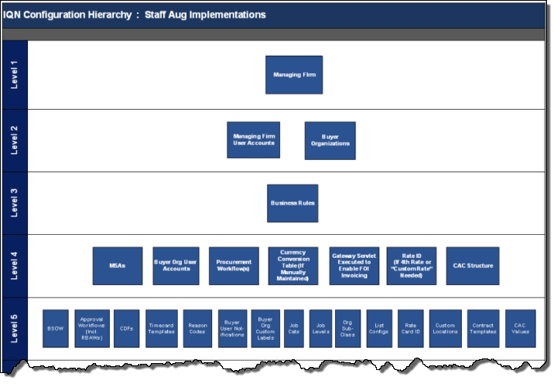

Account Set Up
To view the hierarchy structure in IQNavigator, click the Set Up down arrow located in the header menu bar and then click Accounts (Legacy UI). (The Set Up link in the Alternate UI is located in the personal menu located in the upper right-hand corner of the screen.) The screen refreshes to display the Accounts screen. A sample PSO – Best Practices organization hierarchy is shown below.

EXAMPLE: PSO – “Best Practice” hierarchy
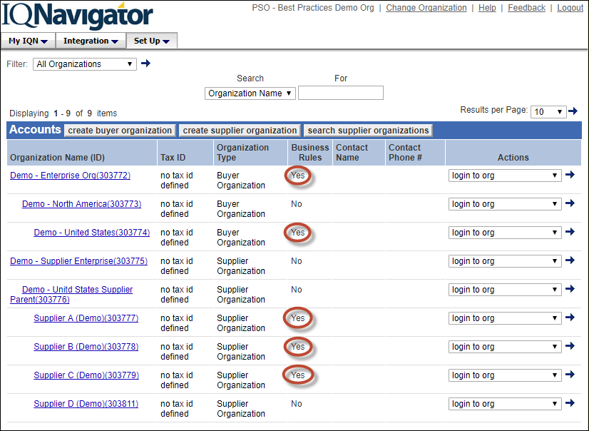
Notice there are three Buyer Organizations and six Supplier Organizations. In this example, business rules are associated to the buyer organizations at the highest level (Demo – Enterprise Org) and a sibling level (Demo – United States). The child level (Demo – North America) is being used as a placeholder and therefore has no associated business rules. Supplier Organizations, typically, have business rules associated to each supplier agency and the parent level acts as an overall administrative entity.
A Managing Firm can also be the overall administrator of an IQN structural hierarchy. In this model, each client organization managed under the PMO/MSP would have a separate client organization structure. Each client would only have access to their specific organization “tree” while the Managing Firm would have access across all client “trees”.
In a hierarchy based system:
- Data ALWAYS flows DOWN the hierarchy.
- User access and visibility flows DOWN.
- Business rules and/or User Roles can be associated at multiple levels throughout the hierarchy.

IQN User Roles
Admins, on either the buyer side or the supplier side, manage their respective user groups. On the supplier side, this includes managing their respective resource pools. A user role (or multiple roles) is assigned and this determines the actions and the visibility the individual will have in IQN. Care should be taken to ensure that the correct role is assigned to reflect the actions the individual is expected to perform.
Click here for a complete list of IQNavigator User Roles and their descriptions.

Key User Roles include:
CAM (Customer Account Representative)
SAR (Supplier Account Representative)
PMO (Program Management Office, i.e., MSP)
Note that the Resource is a subset of the Supplier Organization
The IQNavigator User Role list also includes instructions on how to Proxy (i.e., impersonate) a user.

Login: Choose Buyer Organization
Because there is a one-to-one relationship between Buyer Organization and Supplier in IQNavigator, the login process for buyer side users includes an initial Choose Buyer Organization screen. Users click the down arrow to view the list of valid buyer organizations based on their assigned user role(s). Once logged into the UI, a link in the header menu allows the user to “Change Organization” as needed.
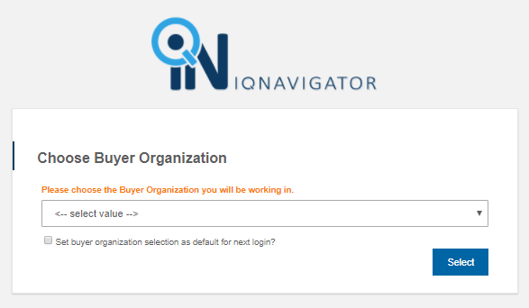

User Interface (UI): Legacy and Alternate
IQNavigator has two active user interfaces, Legacy and Alternate UI. Supplier users only have access to Legacy. Depending on the customer's setup, Managing Firm and Buyer Firm User Roles may have access to both or just to the Alternate UI. Time is entered, either by the Resource, or by the Supplier on behalf of the Resource, in the Alternate UI.

Sample Hiring Manager Dashboard (Alternate UI)
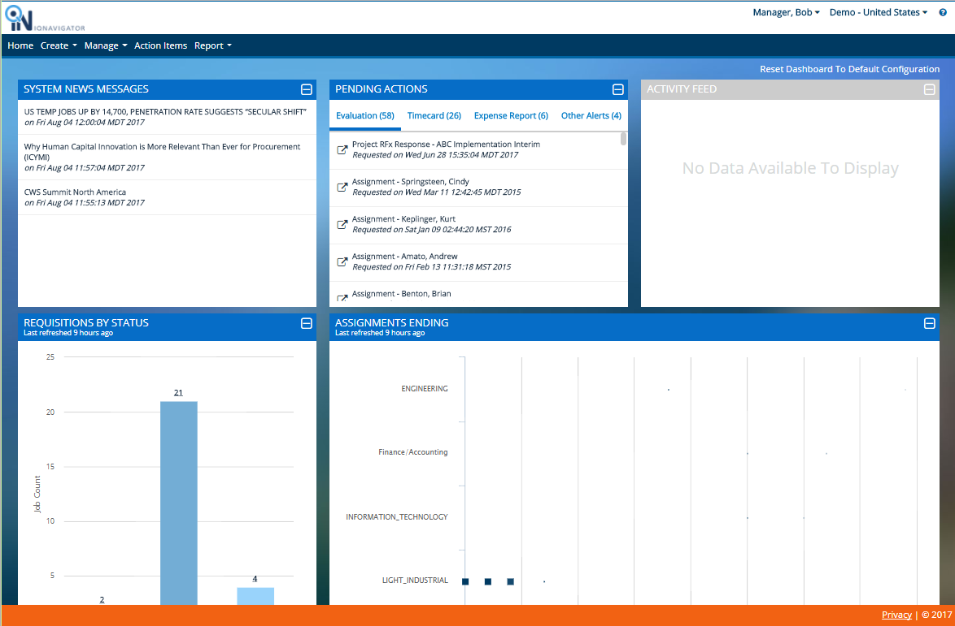
The Buyer (Hiring Manager) dashboard in the Alternate UI is divided into sections to display meaningful data, system messages, and/or actionable links. The header bar menu includes a variety of pull-down selection lists to access key functions, action items, and/or system reports.

Sample Supplier Dashboard (Legacy UI)
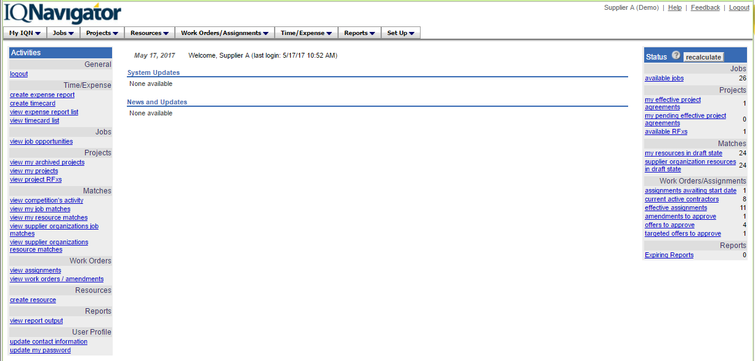
The Supplier dashboard in the Legacy UI is divided into columns. Links to actionable items BY STATUS are posted in the right-hand column. Activity links are located in the left-hand column. The pull-down menu selection lists in the header menu bar provide additional access points to key functions including Set Up.

IQN System Status Definitions
Status terminology used in the Legacy UI can vary from the terminology used for the same status in the Alternate UI. In some instances, a status may only exist in the Legacy UI. The attached chart provides a list of this terminology and how it varies from one UI to another. The list is color-coded to highlight the differences.
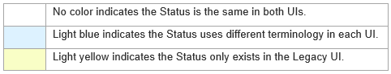

Click here to download list.

Configuration: Profiles, Buttons, & Business Rules
Business rules can be set to apply across the entire business hierarchy or they can be specific to a single organization level.
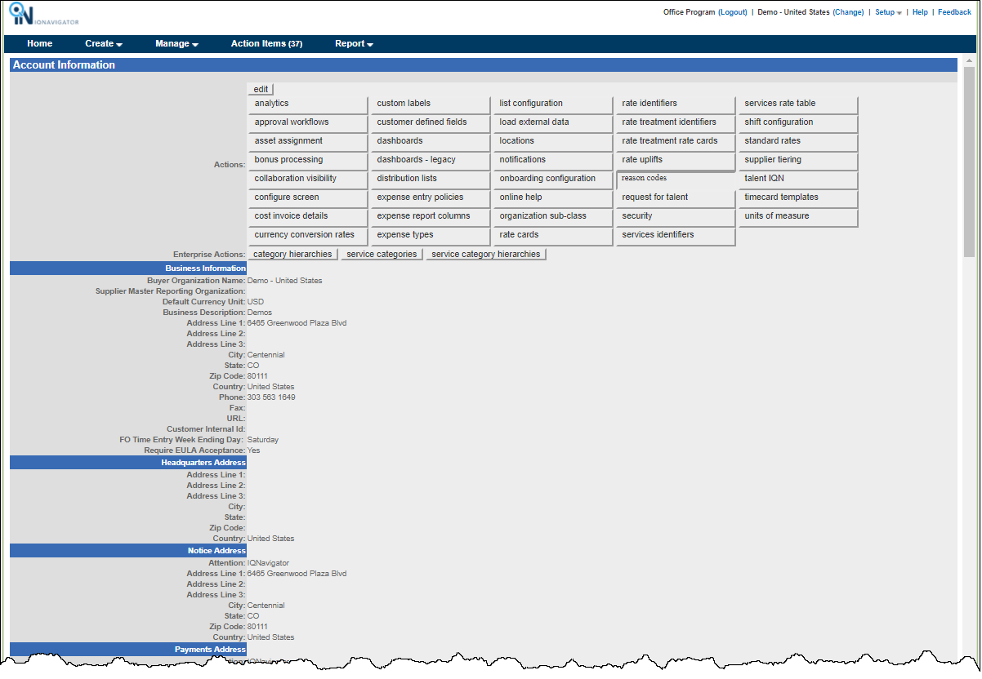
The “buttons” displayed above the business rules profile data fields provide access to a broad range of configuration settings to fine-tune functionality throughout the UI. Click any button and the screen refreshes to display the associated configuration settings. Follow the prompts to make adjustments and remember to <save> to activate your adjustments. Details for system settings can be found in the IQNavigator Admin Configuration Guide.

System Time-Out: Active Session Limit
The time limit for an active session in IQNavigator is 15 minutes. When working with Account or User profile records and configuration settings always remember to <save> frequently to avoid losing your data entries due to automatic system time-out. The Alternate UI alerts users when they are approaching time-out; the Legacy UI does not. An "action" (such as <save>) must be taken to reset the timer "clock". Entering data or navigating through separate screens is not an "action" that will reset the timer.
TIP: When entering data in a new business rules or user profile record, enter "x" in all REQUIRED fields (as indicated by the red asterisk *) and then click <save>. You can then make updates in <edit> mode by <save> data entries in small batches before exceeding the 15-minute threshold.

