PMO: Submit Offer
This document provides Program Office staff with the steps necessary to submit offers to the supplier organization. This guide uses standard IQN VMS configuration. Your specific setup may vary slightly based on your client's configuration.

To review an offer:
- Log in to IQNavigator using your user name and password. Make your Buyer Organization selection during login or use the Change Organization feature once your Home dashboard appears.
- Click the Manage menu drop-down arrow located in the Header Menu bar.
- Click Requisitions. The Positions screen appears.
- Use the Search box () or Advanced Search link to find the Requisition record with the candidate(s) offer you need to review.
• Click the double arrow icon ( ) to change the sort order based on that column
• Click the Configurable Columns link () to add/remove or change the overall display order.
• Use the Items per page selector () to adjust how many items display per screen.
• Click the Quick View overview icon () to review key fields from the Requisition.
- Click the View Candidates link in the Actions column once you locate the Requisition ID line item. The screen opens at the Candidates tab on the Requisition record.
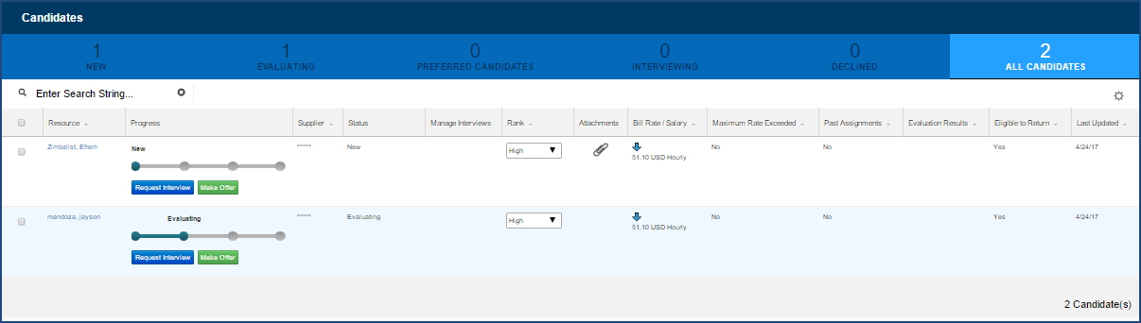
Sample Candidates Screen - Tab View
- Click Evaluating to open the Evaluating tab. This tab lists the Buyer’s (Hiring Manager) selected candidates for which the PMO should extend an offer to the supplier organization.

To submit an offer to the supplier:
- Complete Steps 1 through 6 as described above.
- Click the Make Offer button () in the Progress column (beneath the status bar) for the candidate listed in the Extend an Offer notification. The Edit Assignment screen appears.
- Review the Contract Terms and Assignment Details sections. Make adjustments as needed. Required fields are noted by a red asterisk (*).
- Update the Onboarding Checklist to indicate completed tasks.
- Click Save Draft to save your updates and complete the Offer at a later time, or,
- Click Submit when your entries are complete. An alert message displays: You have submitted successfully. The status bar updates to indicate Pending Supplier Organization Approval and a notification goes to the supplier organization.
If an adjustment is made that increases the budget, the Offer will route back through the customer-side approval process.
If adjustments are made that do not increase the budget, the Offer will route to the supplier organization.
- Use the Back link () near the top of the screen to exit the Edit Assignment screen.
(Once the supplier accepts the offer, the auto-generated assignment record updates to a status of “Awaiting Start Date”—if the Start Date is a future date. A status of “Effective” [Legacy UI] or “Working” [Alternate UI] indicates an active assignment where the Start Date is in the past.)

- Repeat the directions provided above to take action on all remaining Offer to Extend requests.

