Buyer: Manage Requisitions
This document provides managers with the steps necessary to manage requisitions throughout candidate screening, interview, offer, and onboarding stages. This guide uses standard IQN VMS configuration. Your specific setup may vary slightly based on your client's configuration.

To manage requisitions:
- Log in to IQNavigator using your user name and password. Make your Buyer Organization selection during login or use the Change Organization feature once your Home dashboard appears.
- Click the Manage menu drop-down arrow located in the Header Menu bar.
- Click Requisitions. The Positions screen appears.
- Use the Search box () or Advanced Search link to find the Requisition with candidates you want to review.
• Click the double arrow icon ( ) to change the sort order based on that column
• Click the Configurable Columns link () to add/remove or change the overall display order.
• Use the Items per page selector () to adjust how many items display per screen.
• Click the Quick View overview icon () to review key fields from the Requisition.
- Click the View Candidates link in the Actions column once you locate the Requisition ID. The screen opens at the Candidates tab on the Requisition record.
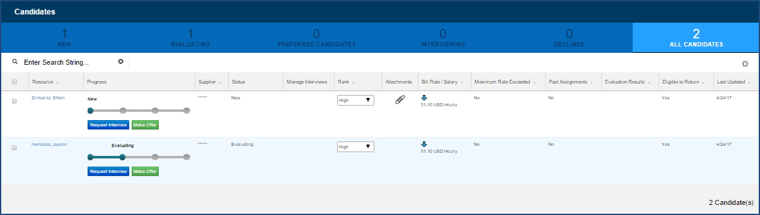
Sample Candidates Screen - Tab View
- Review the list of candidates.
• Move from one filtered list to another just by clicking the filter tab. Notice that the tab also includes the total number of candidates for that category.
• Use the multiple visual cues to identify key elements throughout the filter tabs. For example: A gold star icon in the Preferred Candidate column indicates a preferred candidate. (The PMO or Buyer can status a candidate as preferred. Simply click the default “grey” star icon and it updates to a gold star to designate “preferred” status.)
• Check the progress bar to determine where a candidate is, in the overall review process.
• Look for the paperclip icon ( ) that indicates an attachment such as a resume, certification, license, etc.
• Notice the direction of the arrow in the Bill Rate/Salary column. It indicates whether the submitted rate is below, at, or above the pre-negotiated bill rate.
• Be aware that some columns are strictly informational while others include actionable links. For example: The Tenure Days Remaining column is strictly informational while a click of the icon in the Quick View column opens an abridged version of the Requisition record in a pop-up window.
• Use both the horizontal and vertical scrollbars to ensure you include all content in your review.
NOTE: Content shown on the Candidates screen is DYNAMIC. It changes based on candidate status, actions taken, or even the passage of time. The filter tabs adjust to match these changes. Icon displays and actionable links can change based on current activity and/or status. Take care not to overlook these changes as you work with these filter tabs throughout the candidate review process.

To decline a candidate:
- Use the checkbox in the first column to select the candidate you plan to decline.
- Click the Decline button () that appears at the bottom of the screen only after you click the checkbox. A dialog window opens.
- Select the checkbox to indicate your Reason. This is a required field as noted by the red asterisk (*).
- Optional. Provide additional information to explain your action in the Other Reason text box.
- Click Submit to confirm your intent. The screen returns to the Candidates screen.
- Note: The reason selected and all additional information provided will be made public to the internal and external user(s) who have access to this information.

To compare candidates side-by-side:
- Complete Steps 1 through 6 as described above.
- Use the checkbox to select which candidates to view in a side-by-side comparison.
- Click the Compare Candidates button that is now visible at the bottom of your screen. (Notice that the button also indicates the total number of selected candidates.) The Candidate Comparison screen opens. NOTE: This feature compares profiles stored on ACTIVE Resource records. Candidate profiles provided in attachments are outside the scope of this feature.
- Use both the horizontal and vertical scrollbars to ensure you view all included content. Each candidate profile is a separate COLUMN and the first column identifies the comparison criteria. Note that some categories are strictly informational while others include actionable links.
- Optional. Use the actionable links to Rank, Decline, Request Interview, Offer Position, or View Attachment. There is an additional option for Add Note. The Add Note feature opens a dialog window. Follow the prompts; then click Submit to save and exit.
- Use the Back link () near the top of the screen to exit Candidate Comparison and return to the Candidates screen.

To manage interviews:
- Complete Steps 1 through 6 as described above.
- Click the Request Interview button () in the Progress column beneath the status bar. A dialog window opens.
- Use the prompts to indicate Interview Type, adjust Title, and enter Proposed Interview Time(s). These are all required fields as indicated by the red dot (•).
- Click Choose File to browse for an attachment; then click Attach to complete the action.
- Optional. Use the text box to include any additional content (255 character limit).
- Click Send to generate the interview notifications. The screen returns to the Candidates screen and the record is added under the Interviewing tab.
- If you need to adjust a scheduled interview: Click the icon () in the Manage Interviews column to update or cancel a scheduled interview.

To make an Offer to Extend request:
- Complete Steps 1 through 6 as described above.
- Click the Make Offer button () in the Progress column (beneath the status bar) for the candidate to whom you want to extend an offer. The candidate’s status updates to Evaluating and the record moves to the Evaluating tab.
- Click Submit to confirm your intent. An “Offer to Extend” notification goes to the PMO (Program Management Office).
(Once the supplier accepts the offer, the assignment record updates to a status of “Awaiting Start Date”—if the Start Date is a future date. A status of “Effective” [Legacy UI] or “Working” [Alternate UI] indicates an active assignment when the Start Date is in the past.)

- Repeat the directions provided above to take action on all remaining candidates associated to the Requisition.

