Approver: Approve or Reject a Requisition
This document provides Approvers with the steps necessary to take action (i.e., approve or reject) on submitted requisitions within the user interface. This guide uses standard IQN VMS configuration. Your specific setup may vary slightly based on your company's configuration. (NOTE: Mobile approvals are covered in separate documentation.)

To approve a submitted requisition:
- Log in to IQNavigator using your user name and password. Make your Buyer Organization selection during login or use the Change Organization feature once your Home dashboard appears.
- Click Requisition in the Pending Actions section for a quick review of pending requisition approvals.
- Hover over any line item in the Pending Actions section and click the GO arrow icon to open the full record, or, click the Action items tab in the Header Menu. The Actions Items screen appears.
- Expand the Requisitions section to view the full list of pending requisition approvals. Use the checkbox to the left of each Approval Item to select which items to approve.
Click the Quick View icon to view a summary of the requisition record in a pop-up window. This display includes Job Title, Approver, Rates, Job Summary/Description, Location, Start Date, and End Date. You can click the View Details tab at the bottom of the display to go to the full requisition record, or click X to return to the Action Items display.
- Click the Approve button located above the column display. The system processes your request and routes the requisition to suppliers based on the associated distribution/tiers rules.

To reject a submitted requisition:
Follow the same process steps as above through Step 4 to click the Action items tab in the Header Menu.
- Expand the Requisitions section to view the full list of pending requisition approvals. Use the checkbox to the left of each Approval Item to identify which items to reject.
Click the Quick View icon to view a summary of the requisition record in a pop-up window. This display includes Job Title, Approver, Rates, Job Summary/Description, Location, Start Date, and End Date. You can click the View Details tab at the bottom of the display to go to the full requisition record, or click X to return to the Action Items display.
- Click the Reject button located above the column display. In the dialog window, use the checkbox option to indicate the reason for the rejection. Optional. Use the text box to include additional comments.
- Click Submit to exit the dialog window and return to the Action Items list view. A Rejection Successful alert message displays and a notice goes to the business stakeholders.

Overview of Action Items/Requisitions Features
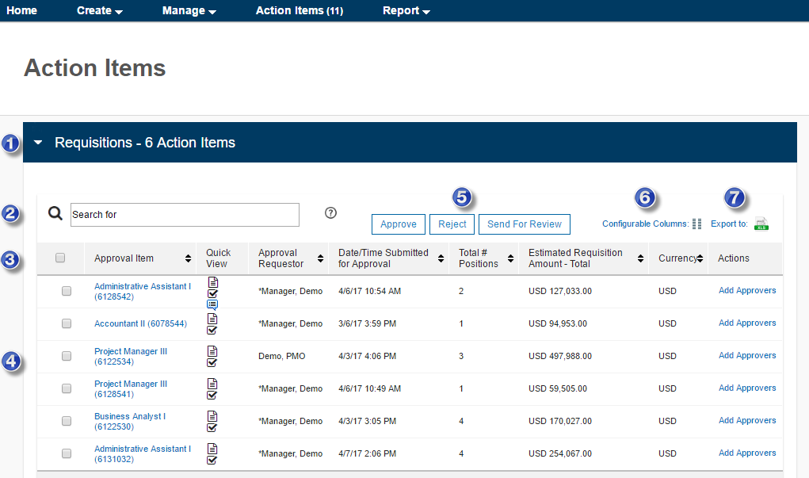
A title bar displays on the Action items screen to identify both the category and the total number of actionable items for that section. All sections display as collapsed by default. Click the down arrow or anywhere in the title bar to expand the section and view the items list. Click again and the section returns to the collapsed view.
The search feature filters action items by key data points including Approval Item, Approval Requestor, Date/Time Submitted for Approval, Total # of Positions, Estimated Requisition Amount – Total, and Currency. This includes auto suggestion/type ahead functionality that recommends items to match what you type for ease of use. No matches? Just click the search icon () or press <Enter> to generate your search results.
The header bar not only includes column headers to identify key data points, it also incorporates several “action” features. Use the checkbox to select ALL items in the list if you intend to take the same action against all items. Use the up/down arrow () to sort all items in ascending/descending order by a specific category.
The items list provides quick visibility to all items as well as easy access to each item’s complete record. Use the checkbox to select ONLY those items against which you want to take the same action. Click the Job/Position Title in the Approval Item column to view its full record. Click the Quick View icon(s) to view various highlights from the complete record. (Icons will vary based on status and actions taken. Click to open a Summary Approval window, to view an Approval in Process status bar, to view items submitted for review, etc. Just hover over the icon and a text box displays to identify it by type. Click X to close the pop-up and return to the list.) The Actions column lets you add Approvers as needed.
There are two standard action buttons available to the Approver, Approve or Reject. Use the checkbox in the header bar to select ALL items in the list, or, use the checkbox adjacent to each line item to select items on an individual basis. Click Approve to accept the selected item(s) as is and move it forward in the workflow. Click Reject, indicate the reason for your rejection (including comments), and it returns the item(s) to the respective business stakeholder’s queue. Optional. Click Send for Review when you need input from another business stakeholder(s). This selection includes an option for comments and/or attachments. Availability is based on configuration settings.
The Configurable Columns feature gives you a broad range of control over the display format for the items list. Some columns are required by default and outside the scope of configurable options. Just click to expose the shuffle-box setup and you can change the display order of the available columns, add/remove columns, or shuffle the columns to the order of your choice. The “Reset to Default” button lets you reverse your changes back to the original display with a single click! Click X to close the pop-up window and return to the list.
If available, the Export feature lets you extract your complete list into an Excel® spreadsheet with a single click. The export incorporates any adjustments made to the sort order or column headers.

